LAB PROGRAMS OUTPUT

DAY -1

1A]

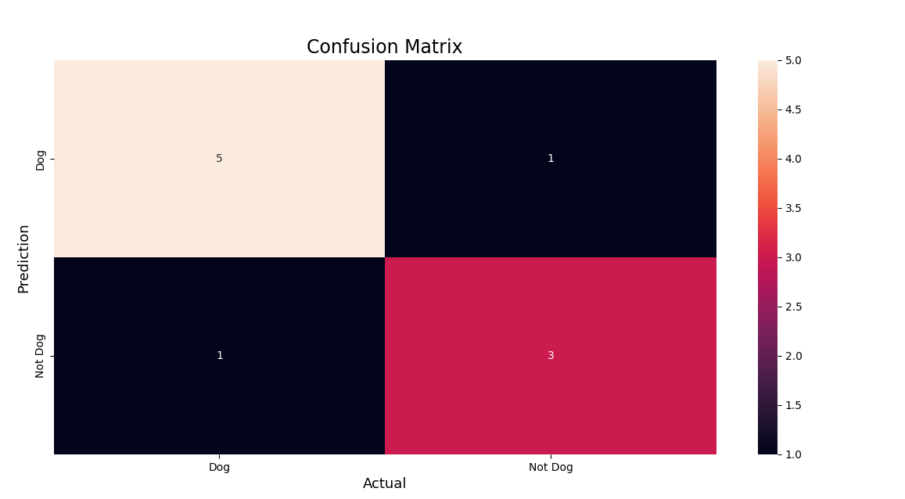

1b]

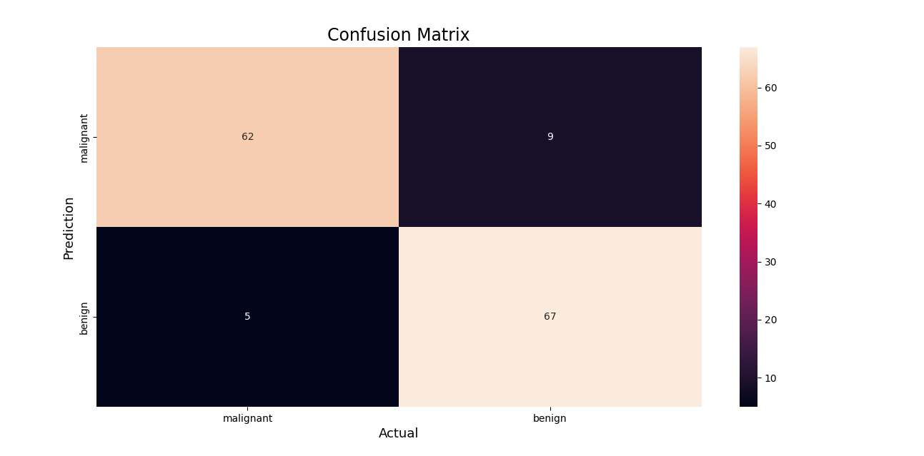

2]Multi-class confusion matrix

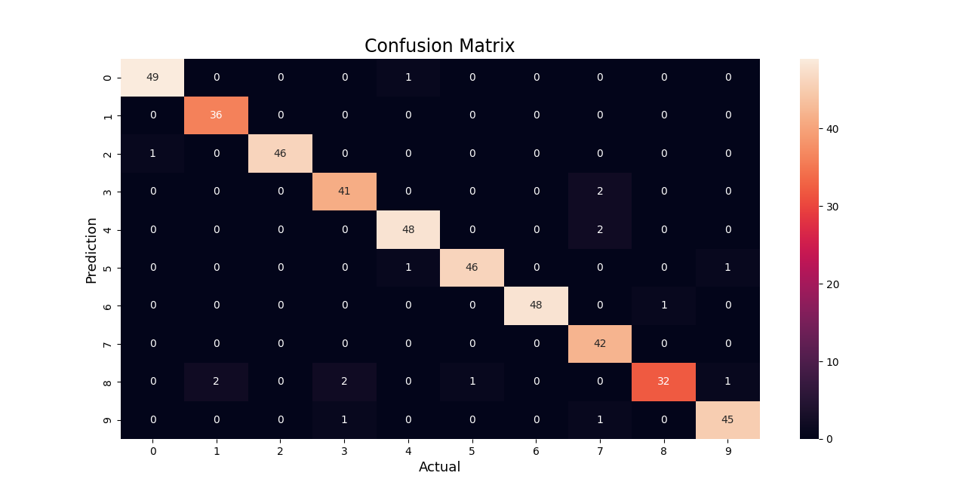

3]Overfitting problem

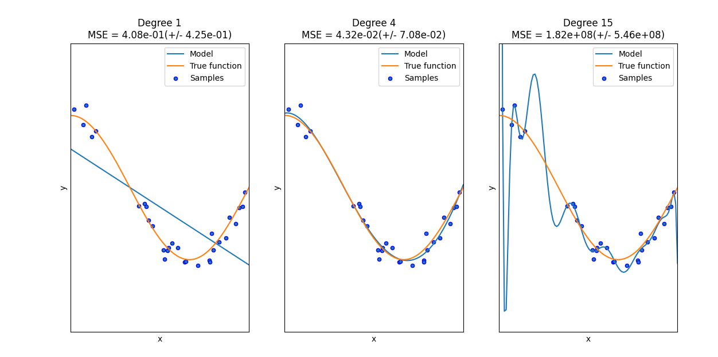

4]Linear regression

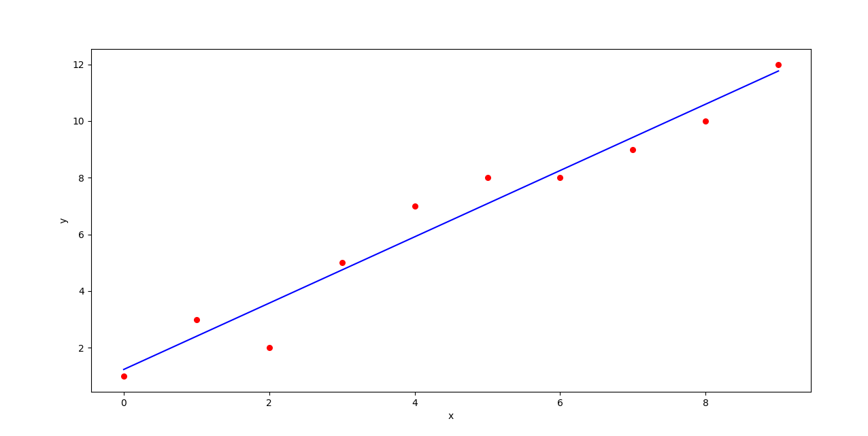

Estimated coefficients:

b_0 = 1.2363636363636363

b_1 = 1.1696969696969697